ROAD ACCIDENT ANALYSIS USING SQL

-- Q1 How many accidents occoured in urban areas vs Rural areas?

select Area, COUNT(AccidentIndex) AS Total_accident

from [dbo].[accident]

group by Area

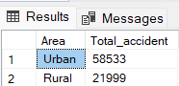

-- Q2 Which day of the week has the highest no of accidents?

select Day, COUNT(AccidentIndex) as Total_accidents

from [dbo].[accident]

group by Day

Order by Total_accidents desc;

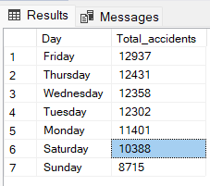

-- Q3 What is the average age of vehicles involved in accidents base on their type?

select VehicleType, AVG(AgeVehicle) as AVGVEHICLE

from [dbo].[vehicle]

where AgeVehicle is not null

group by VehicleType

order by AVGVEHICLE desc ;

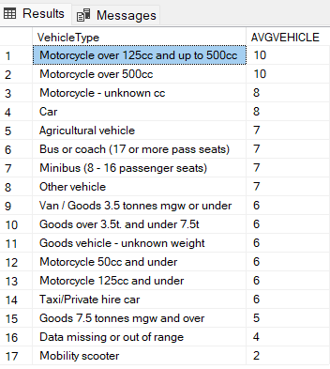

--Question 4: Can we identify any trends in accidents based on the age of vehicles involved?

SELECT

AgeGroup,

COUNT([AccidentIndex]) AS 'Total Accident',

AVG([AgeVehicle]) AS 'Average Year'

FROM (

SELECT

[AccidentIndex],

[AgeVehicle],

CASE

WHEN [AgeVehicle] BETWEEN 0 AND 5 THEN 'New'

WHEN [AgeVehicle] BETWEEN 6 AND 10 THEN 'Regular'

ELSE 'Old'

END AS AgeGroup

FROM [dbo].[vehicle]

) AS SubQuery

GROUP BY

AgeGroup;

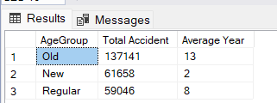

--Q5 Are there any Specific weather condition that contribute to severe accidents?

\

SELECT WeatherConditions,severity ,COUNT(AccidentIndex) AS total_accidents

FROM [dbo].[accident]

group by WeatherConditions,severity

order by total_accidents Desc;

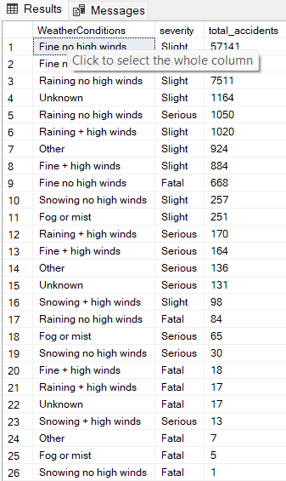

--Q6 DO accidents often involve impacts on the left hand side of vehicles ?

select LeftHand,count(AccidentIndex) as Total_accidents

from [dbo].[vehicle]

group by LeftHand

having

LeftHand is not null

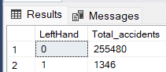

--Q7 Are there any relationship between journey puroses and the severity of accidents?

SELECT severity, COUNT(a.severity) as TC,

v.JourneyPurpose

from [dbo].[accident]a join [dbo].[vehicle] v

on

a.[AccidentIndex]=v.[AccidentIndex]

group by a.severity,

v.JourneyPurpose

order by TC desc

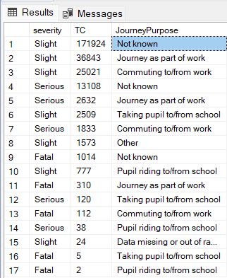

--Q8 Calculate the average age of vehicle involve in accident considering day light and pint of Impact.

SELECT

A.[LightConditions],

V.[PointImpact],

AVG(V.[AgeVehicle]) AS 'Average Vehicle Year'

FROM [dbo].[accident] A

JOIN

[dbo].[vehicle] V

ON A.[AccidentIndex] = V.[AccidentIndex]

GROUP BY

V.[PointImpact], A.[LightConditions]

HAVING LightConditions='Daylight'

